**WIREFRAME SCHOOL MANAGEMENT SYSTEM**

**HOME**



**Authentification**

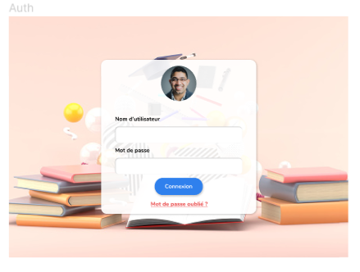

**Admin**

